**183. Why do we Need Angular's Help**

* -: So let's take a closer look at how Angular works together with forms .
* Consider this form .

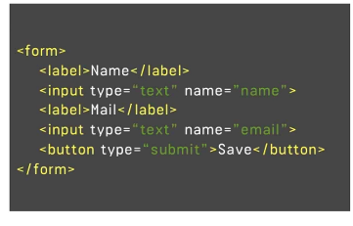

* This is the HTML code of a form, which you might use and there is nothing Angular specific about this code .

* It's normal HTML code, which you would place in your HTML documents to maybe display a form like this with an input for the username and the input for the email address .
* Now, as mentioned in the last video, Angular's job now is to allow you to retrieve the values the user entered here and also to check some other things like is the form valid? Did the user enter valid information? And all that, of course, will happen in JavaScript, in TypeScript .
* So on the Angulartuse side of your app, you could say .
* So you somehow need to be able to parse the values the user enters and you somehow need some JavaScript object representation of your form in your TypeScript code to work with .
* So this object could look something like this .
* It is more complex in reality but these would be the key features we need, for example .
* We need to have the value of the form and there it would be convenient if we would have key value pairs where the key refers to the name of input, like for example name or email as specified in the HTML code and then it holds the values the user entered .

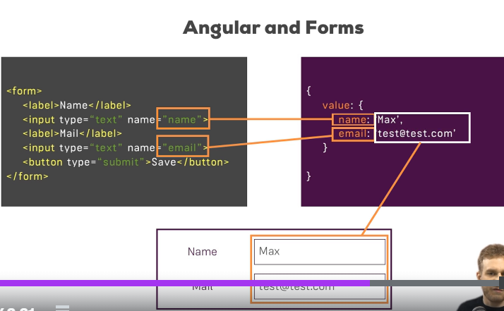

* This would make it super simple for you to work with these values in your TypeScript code and to do something with the values the user entered .
* It might also be helpful if some metadata was stored, like for, for example if the form is valid and this would be changed to false, for example, if the email address wouldn't be a valid email address .
* This is what Angular does for you .
* It allows you, or it gives you actually such a JavaScript object representation of your form making it simple for you to retrieve user values and to see the state of the form and to work with it .
* Now in the next lectures, we're going to take a detailed look and we will understand how exactly it works how we can configure it, what we can do with it, how we can reset it, and much more .